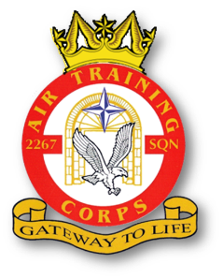 |  | 2267 (Brize Norton) Squadron RAF Air Cadets  2020 Training Programme  March 2020  V1.10 dated 9 Mar 20 |  |  |  |  |  |  | 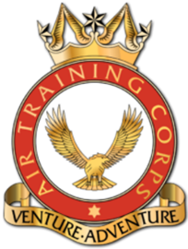
Date | Day |  | New Entry (Junior Cadet) | Second Class (Enroled) | First Class | Leading | Senior | Master |  | Notes
03 Mar 20 | Tue |  | Induction | Climatic Injuries |  | Aircraft Handling & Marshalling |  |  |  | -
05 Mar 20 | Thu |  | NO CADET ACTIVITIES – Staff Meeting
10 Mar 20 | Tue |  | Induction | Blue Leadership |  | Communications – 10 Minute Talks |  | Leadership Assist |  | -
12 Mar 20 | Thu |  | Induction | First Class Books | Principles of Flight | Aircraft Handling & Flying Techniques |  | Intro to RAF Brize Norton Prep |  | Annual Dinner Prep
17 Mar 20 | Tue |  | Induction | Ex SpySat |  |  |  |  |  | Bitesized History
19 Mar 20 | Thu |  | Induction/Initial Kitting | First Class Books | Principles of Flight | Aircraft Handling & Flying Techniques |  | Syllabus Assist |  | Bitesized History
24 Mar 20 | Tue |  | Induction | Guest Speaker (PJI) |  |  |  |  |  | -
26 Mar 20 | Thu |  | Enrolement | First Class Books | Principles of Flight | Aircraft Handling & Flying Techniques |  | Syllabus Assist |  | -
31 Mar 20 | Tue |  |  | RAF Brize Norton Intro | Moral Maze | Aeromodelling & Diorama Skills |  | Flight Sim Instruction |  | -

