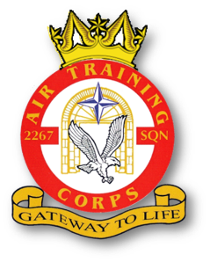 |  | 2267 (Brize Norton) Squadron RAF Air Cadets  2020 Training Programme  April 2020  V1.1 dated 2 Mar 20 |  |  |  |  |  |  | 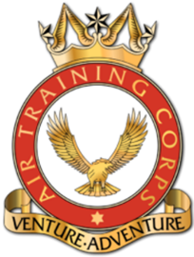
Date | Day |  | New Entry (Junior Cadet) | Second Class (Enroled) | First Class | Leading | Senior | Master |  | Notes
02 Apr 20 | Thu |  |  | First Class Books | Principles of Flight / Exam | Aircraft Handling & Flying Techniques |  | Flt Comp Prep |  | Bitesized History
07 Apr 20 | Tue |  |  | First Class Books | Adventure Training |  | Listening Skills Course |  |  | -
09 Apr 20 | Thu |  |  | First Class Books | Principles of Flight / Exam | Aircraft Handling & Flying Techniques Exam |  | Syllabus/Exam Assist |  | -
14 Apr 20 | Tue |  |  | First Class Books | Inter-Flt Competitions |  |  |  |  | -
16 Apr 20 | Thu |  |  | Guest Speaker |  |  |  |  |  | -
21 Apr 20 | Tue |  |  | First Class Books | Critical Thinking |  |  |  |  | Band
23 Apr 20 | Thu |  |  | First Class Books | Sports (Prep for Wg Comp) |  |  |  |  | -
28 Apr 20 | Tue |  |  | First Class Books | Squadron Drill Night |  |  |  |  | -
30 Apr 20 | Thu |  |  | First Class Books | Airmanship | RAF Regiment Evening |  |  |  | -

