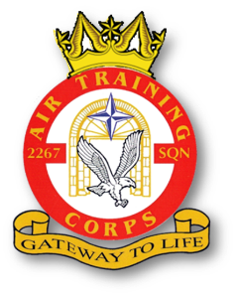 |  | 2267 (Brize Norton) Squadron RAF Air Cadets  2020 Training Programme  February 2020  V1.7 dated 4 Feb 20 |  |  |  |  |  |  |  | 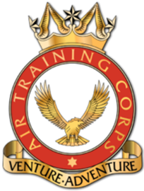
Date | Day |  | New Entry (Junior Cadet) | Second Class (Enroled) | First Class | Leading | Senior | Master |  |  | Notes
04 Feb 20 | Tue |  |  | Kitting | Communication Skills (Presentations) |  |  |  |  |  | -
 |  |  |  |  | (2 mins) | (10 mins)
06 Feb 20 | Thu |  |  | Guest Speaker (WO Joe Lambley-Steele, SWO Odiham) |  |  |  |  |  |  | -
11 Feb 20 | Tue |  |  | First Class Books | Effects of Controls | Aircraft Handling & Flying Techniques |  | Syllabus Assist |  |  | -
13 Feb 20 | Thu |  |  | Sport |  | STEM Activities |  |  |  |  | -
18 Feb 20 | Tue |  |  | Quiz Night & Annual Dinner Prep |  |  |  |  |  |  | -
20 Feb 20 | Thu |  |  | Inter-Flt Competitions |  |  |  |  |  |  | -
25 Feb 20 | Tue |  | Taster Night | Sqn Showcase Night (First Aid, DofE, Low Ropes, Flt Sims, Drill) |  |  |  |  |  |  | -
27 Feb 20 | Thu |  | Induction | First Class Books | Effects of Controls | Aircraft Handling & Flying Techniques |  |  | Syllabus Assist |  | -

